Long live Cholera Cemetery
City officials, historians rededicate grounds
August 10, 2018 - By ANDY OURIEL, Sandusky Register
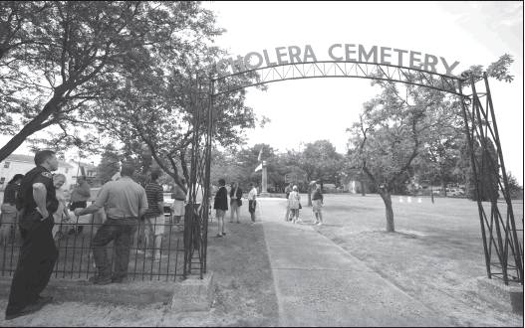
Sandusky officials rededicated the Cholera Cemetery Wednesday afternoon. During the past year, officials made many improvements to the Harrison St. green space, which included improving the sign.
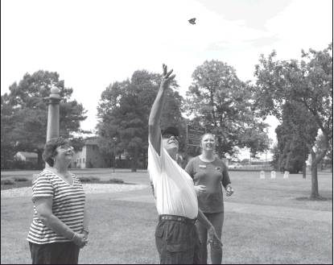
A monarch is released the dedication. More at sanduskyregister.com
Register photos/ERIN McLAUGHLIN

SANDUSKY
As 357 spirits rest in peace at the Cholera Cemetery, its overall spirit remains alive and well throughout Sandusky.
About 30 community members attended Wednesday’s rededication ceremony, in which officials outlined several recent upgrades happening at the Harrison Street green space.
Within the past year, city public service workers:
Touched up a monument, or obelisk, acknowledging those dying from the disease
Placed landscaping materials around the memorial
Added a butterfly pollinator patch to strengthen its Monarch City designation; The special garden is filled with blooming, vibrant flowers, milkweed and nectar plants, where butterflies can pollinate them, thus providing proper fertilization and nutrition.
Refurbished the historical marker (Thanks to the Erie county Historical Society)
Removed dead and trimming overgrown trees
Painted the “Cholera Cemetery” sign with a new coat of green paint
Enhanced the signage
These upgrades mark the cemetery’s first such major makeover in about 50 years. Many pushed for these changes, namely city commissioners Dave Waddington and Dick Brady. “This property had a significant but tragic history for Sandusky, through the cholera epidemic,” Brady said when addressing the attendees. “This property also had a history of neglect, unfortunately.”

Brady spoke how descendants of those buried there vigorously protested against a proposed athletic field to co-inhabit this space in the early 1900s. They also fought against a former, and unknown, city commissioner allowing his livestock to graze the grounds.

He then explained why, to this day, many people want to preserve the Cholera Cemetery — and equated it to present-day culture, and compassion, displayed in Sandusky.

“Our forefathers were very resilient. This scourge was not of their making. It was brought on by travelers passing through Sandusky. There were many heroes — doctors and nurses from Cleveland, Cincinnati and Philadelphia — that came to Sandusky to fight this outbreak, risking their lives and, in some cases, losing their lives. In this crisis, you had residents helping strangers, and strangers helping strangers. That spirit continues to live in this city today. I am certain of that.”

