Castalia church has rich history
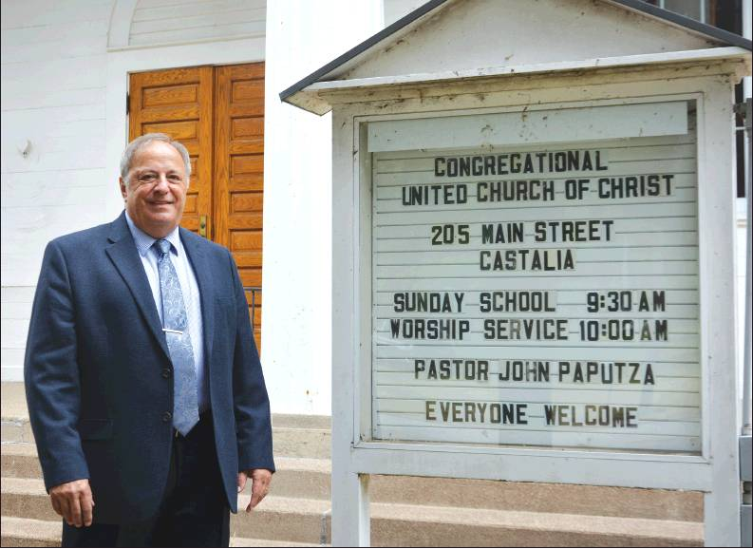
August 4, 2018, By CAITLIN NEARHOOD, Sandusky Register
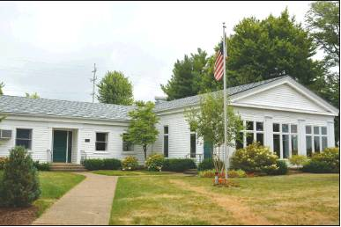

Register photos/CAITLIN NEARHOOD
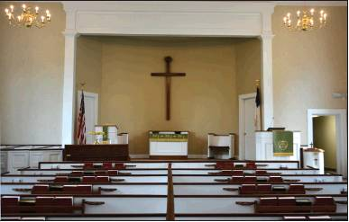
ABOVE: Pastor John Paputza stands in front of Castalia Congregational United Church of Christ on Aug. 1. (R) An educational wing was constructed at in 1960.
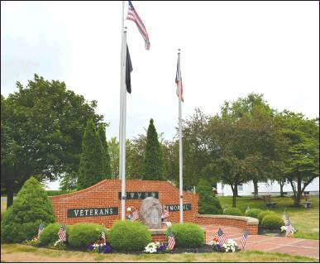
The veterans memorial is located on the property. (RIGHT) The sanctuary.

CASTALIA
You’ve likely driven past this church multiple times. Across from the village’s famous duck pond is Castalia Congregational United Church of Christ at 205 Main St. The church has its worship service at 10 a.m. Sundays with Sunday school at 9:30 a.m. Bible studies occur on Sundays and Thursdays.
The church formed in 1835 and its sanctuary was built in the 1840s. An educational wing of the church was constructed in 1960, which includes a fellowship hall. More than 85 people attend the church, pastor John Paputza said.
When the church opened, it was supported by another church in New England. “The sad part is we lost touch with the church and were never able to find that mother church,” Paputza said. Also in that time period, the church was given a clock in the 1840s. “The clock still works,” Paputza said.

This month, Paputza has served at the church for 40 years. He graduated from Sandusky High School in 1964 before serving in the Vietnam War. Soon thereafter, he began work at the church.

In Paputza’s four decades there, the church added a ramp to become more handicapped accessible, a steeple and has undergone renovations, with the most recent occurring in the sanctuary for the church’s 175th anniversary. About six years ago, the church donated land for a veterans memorial, near the Castalia post office. A Little Free Library also can found on church property on North Water St.

A yearly tradition at the church is a sunrise service 6:30 a.m. on Easter morning at the Castalia Cemetery. “There are about 70 to 80 people who come out there for that,” Paputza said.

For community involvement, United Church of Christ and Grace Lutheran Church in Castalia co-host worship services during the Cold Creek Festival each year. “That’s something we enjoy,” Paputza said. The church’s outreach goes farther than the village limits. It supports the food pantry at Grace Lutheran Church, provides money for hunger outreach in Castalia, the U.S. and around the world. “That’s one of the projects we feel strongly about,” Paputza said. Members of the church have volunteered at nonprofits in the Sandusky area and its youth have helped at Victory Kitchen in on Hayes Ave. in Sandusky. The church also hosts a rummage sale each year for the community in addition to a community dinner in the fall. “Wherever there’s a need, we’ll give it to them,” Paputza said. Those who attend United Church of Christ make it a welcoming place. “It’s a faithful, loving congregation,” Paputza said. “They take care of one another.”

Get to know Castalia Congregational United Church of Christ
n Address: 205 Main Street
n Phone: 419-684-7152
n Website: christchurchhuron.org
n Facebook page: Castalia Congregational United Church of Christ (@ CastaliaUCC)

