Cooke Complex makeover - $8.5 million renovation to feature indoor mall
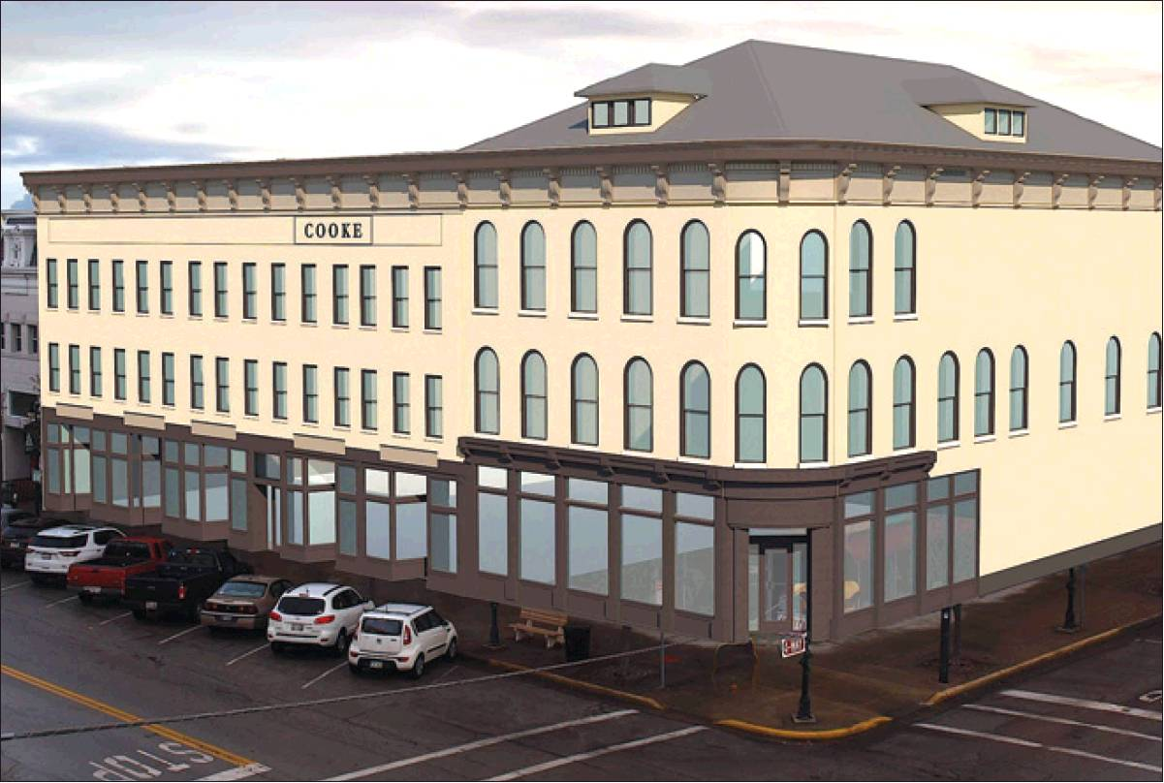
August 7, 2018 - By ANDY OURIE, Sandusky Register

An artist rendering reimagines what the Cooke Complex could look like. An $8.5 million projects calls for significant updates to the downtown Sandusky building on Columbus Avenue and East Market Street.

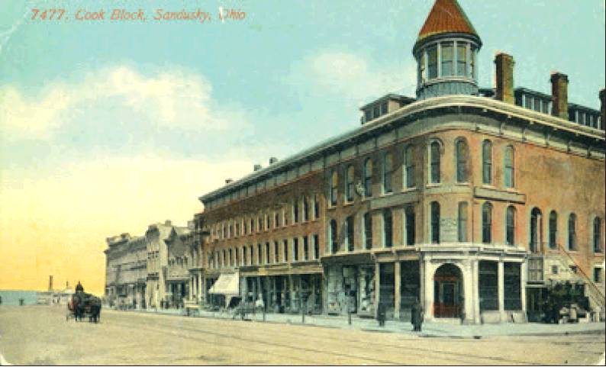

An undated postcard image shows the Cooke Complex in downtown Sandusky.
Provided photo/SANDUSKY LIBRARY HISTORY BLOG

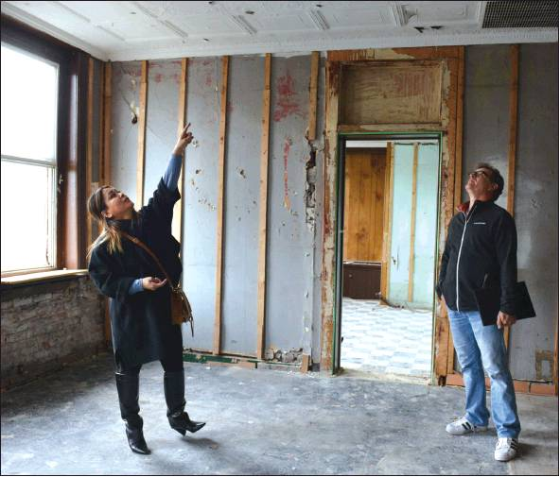

Meghan Hogrefe points out the details on the ceiling as she and her husband, Rick, walk through the Cooke Complex in downtown Sandusky in February. The two are undertaking an $8.5 million project to revitalize and modernize the structure.
Register file photo/ ERIN McLAUGHLIN

Editor’s note: Each week, the Register is highlighting a historical feature related to a project undertaken by developers Meghan and Rick Hogrefe. This is the first of several installments.
SANDUSKY
Earlier this year, area developers Meghan and Rick Hogrefe embarked on a tough task to revitalize the near-blighted Cooke Complex. They intend to invest about $8.5 million of their own money to resurrect this storied downtown structure.
Blueprints show them repairing the facade to its late 1800s appearance; restoring the third floor into a ballroom and theater; creating an indoor arcade filled with local vendors; building out spaces for prospective businesses; among other uses.
If all goes according to plan, the Hogrefes envision an opening ceremony set for sometime in 2020. “There is so much historical value with this building, and we want people to, once again, be proud of it,” Meghan said.
Rick doubled down on her assessment. “We need to bring this building back,” Rick said. “If we succeed, I believe we will have accomplished something great not just for us but for the entire city.”
The Cooke Complex offers a vast history, including where many businesses got their starts. With help from the Sandusky Library History Blog, here’s a quick timeline of notable events:
1850s: Sandusky’s Cooke Block, at the northeast corner of Columbus Avenue and Market Street, came into existence. Ellie Damm wrote in “Treasure by the Bay” that the north section, known as the Union Building, was built first, along Columbus Avenue.
1866: Wildman Mills erected a large building at the corner of Columbus Avenue and Market Street, and he sold the building to Charles E. and George A. Cooke.
1876: The Cooke Block and the former Union Building consolidated. Sandusky officials met in both buildings to conduct city business.
1882 through 1899: The Melville Brothers ran a wholesale and retail drug business in the main corner building of the Cooke Block. Josh B. Davis and J. H. Wagenet were insurance agents in the upper levels of the building.
1908: The Commercial National Bank served as the main business in the Cooke Block’s corner building. A variety of other businesses operated from the Cooke Block, including insurance and real estate agents, lawyers, doctors, restaurants and retail stores.
1923 into the 1930s: Fred A. Martin operated a wholesale and retail confectionery business in the Cooke Block. By the time Martin’s Confectionery was in the Cooke Block, streetcars and automobiles had replaced horse-drawn vehicles.
1938: Walgreen’s Drugstore was at 172 Columbus Ave., where Martin’s had formerly been in business.
1960s into the 1980s: Holzaepfel Brothers Sporting Goods operated from the northeast corner of Columbus Avenue and Market Street.

