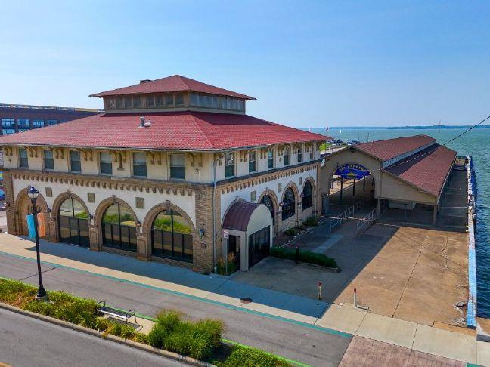
Process to redevelop Boeckling Building begins
By ANDY OURIEL Sandusky Register 2/9/2026
SANDUSKY - Sandusky officials took another step to begin the process of redeveloping a historic waterfront structure, an attached pier and a nearby gravel lot.
During a recent public meeting, city commissioners formally accepted the Boeckling Building as donated property. While first announced this past summer, the building more recently and officially came into the local government's possession.
It circles back to a deal, authorized in 2021, involving Cedar Fair, now Six Flags, the parent company of Cedar Point, investing $100 million over a two-decade-long period to, in part, create and/or improve many forthcoming facilities and infrastructure initiatives throughout Sandusky.
Among the possibilities for this site would potentially involve a water taxi system, transporting passengers to and from Cedar Point across Sandusky Bay. Another prospect for this site would be turning the longtime empty building into space for retail-based opportunities. "I want to thank Cedar Point for their partnership and cooperation," city manager John Orzech said. "This is a historic building in a key location on our waterfront, and we're ready to take the next step by finding a redevelopment partner. Our goal is to bring the building back into active use while maintaining access for the Jet Express and potentially future water taxi service."
Here's a guide to understand this process:
• The history: "The Boeckling Building, located at 105 W. Shoreline Drive, was originally constructed in 1928 by George Boeckling to serve as the winter headquarters for Cedar Point," according to a city statement. "The building has been home to various businesses and offices over the decades, but it has been vacant since 2022. The site includes the pier and dock area that serves the Jet Express passenger ferry during the summer season."
• The context: The donation originated from a 2021 agreement with Cedar Point and Sandusky's city commission. A finalized donation agreement initially arose in July 2025.
• The priority: "The Boeckling Building site is identified as a major redevelopment priority in the Downtown Sandusky Master Plan, adopted in 2021," the city statement read. "The plan calls for reinvestment and new uses at the site that strengthen the waterfront district, support walkability and create a more active connection between downtown and the water."
• The timing: For the six months, between July and January, city officials "completed due diligence at the site, including reviewing existing studies, (multiple phases of) environmental information, evaluating existing conditions and completing a walkthrough by the" city's building official," the statement read.
• The next steps:" The selected development team will be expected to lead all aspects of project planning and delivery and work through the city's public approval process. The city expects proposals to be market-feasible with a clear, practical path to construction, align with the downtown master plan and the city's strategic plan and reflect community priorities through additional public and stakeholder engagement. Redevelopment proposals are expected to consider public space, pedestrian connectivity to the surrounding walkway and pathway network, waterfront access with continued capacity for the Jet Express and potential future passenger ferry service, and prioritization of historic preservation.
• The upcoming deadline: To begin the next phase of work, the city released a redevelopment request for qualifications (and) is now seeking a qualified team to work with the city and community on a plan for the property. Project teams intending to respond must submit a letter of intent by Feb. 13. Qualifications are due March 27."
People and developers can direct questions to Colleen Gilson, the city's community development director, at cgilson@cityofsandusky.com. The full plan can be viewed at cityofsandusky.com/boecklingrfq.

